Cairo university

Faculty of computers and artificial intelligence

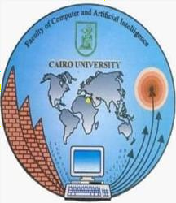**Project name: Super Market**

|  |  |  |
| --- | --- | --- |
| **Name** | **ID** | **Section number** |
| Salma Essam Mohamed Mohamed  Hamad | 20200777 | S14 |
| Yomna Alaa Elsayed Aly Darwish | 20200773 | S14 |
| Maram ashraf ahmed Elazab | 20200507 | S14 |
| Maryam Shehab El Din Gomaa | 20200844 | S23 |
| Eman Ramadan Mostafa | 20200104 | S13 |
| Hagar Maher Emam | 20200615 | S12 |